Lab Report 2 – Simple Circuits, Aidan Chin and Aidan Carey

**Introduction/Motivation:**

The purpose of this lab was to familiarize us with more of the equipment in the lab, especially the multimeters and power supply. The multimeter is used to measure the voltage, amperage, or ohms. The power supply is used to supply power at a measured voltage and amperage to a circuit. We also utilized breadboards and some resistors. The breadboard is a convenient and tidy way to prototype circuits. The resistors are a circuit element that has a set resistance value. Power dissipation is the amount of power in the circuit lost to resistances, power is in Watts, Volts*Amps. The 2 circuits that we created was a parallel circuit; 2 resistors side by side, both connected to the same part of the same wire and a series circuit, which is 2 resistors, wired in a line, so one is connected to the end of the other. To calculate current or voltage we can use the formula V=IR where V is volts, I is current and R is resistance. To find the resistance in a parallel circuit we use the formula 1/R = 1/R1 + 1/R2, where R is the resistance of the whole circuit and R2, R1 are the resistances of the components. In series, to calculate the resistance uses a more simple formula of R = R1+R2 using the same variables from before.

**Experimental Diagram + Table:**

|  |  |  |
| --- | --- | --- |
|  | Labeled Resistance | Measured resistance |
| Resistor 1 | 1950 | 2000 |
| Resistor 2 | 1950 | 2000 |

Resistors in series

Measuring current with multimeter in series measuring voltage with multimeter in parallel

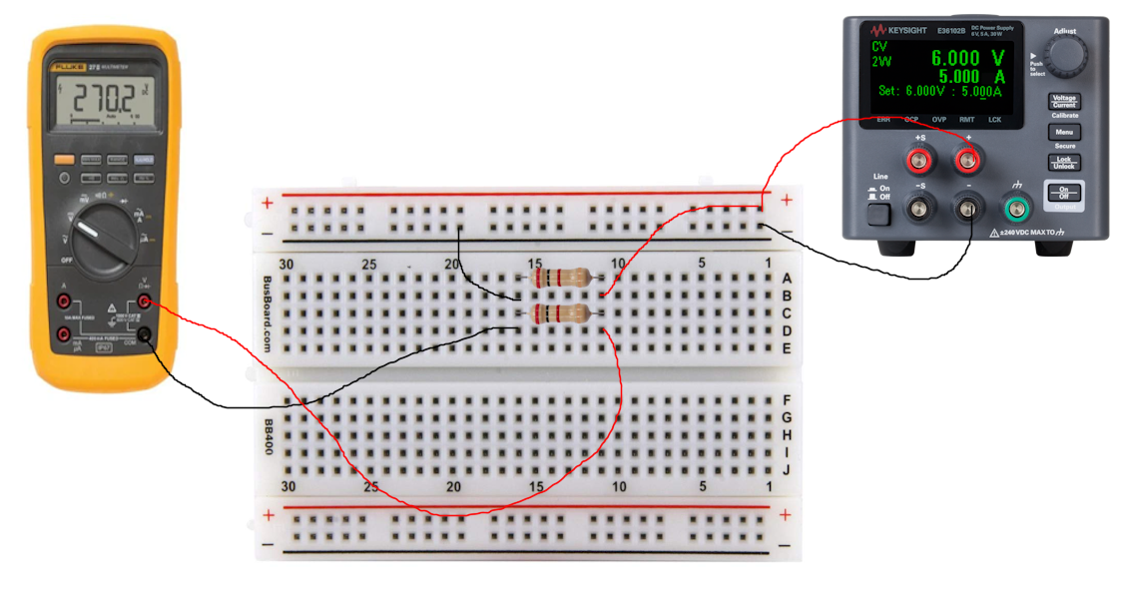

Measuring voltage with multimeter in parallel measuring voltage with multimeter in series

|  |  |  |  |
| --- | --- | --- | --- |
| Resistors in Series |  | Resistors in Parallel |  |
|  |  |  |  |
| Voltage applied | 5.92V | Voltage applied | 5.92V |
| Voltage across resistor | 2.96V | Voltage across resistors | 5.94V |
| Measured current between resistors | 1.48mA | Measured current through resistors | 5.94mA |
| Calculated current | 0.00148A | Calculated current | 0.00592A |
| recalculated current | 0.001517948718A | Power dissipated | 0.033995008W |

**Analysis of Resistors in Series**

For the resistors in series, we recreated the circuits from the lab instructions. using the breadboard and wires to connect the 2 2000 Ohm resistors in series. Setting the output voltage to 6V had a real output of 5.92 V. Next, using the multimeter, we measured the voltage across 1 resistor and got a value of 2.96, exactly half of the voltage applied. This is just as expected as the circuit analysis shows that in series the voltage drop across the whole circuit should be equal to applied voltage, there are only 2 components in the circuit, so the voltage drop across each of them should be half of the voltage applied. Next we measured the current between the resistors. To do this we broke the circuit and inserted the multimeter in between and got a measured value of 1.48 mA, this is also expected because the formula for current is V/R=I and we plug in 5.92/2000 = .00148 A which is equivalent. Finally in the end we measured the actual values of resistance in the resistors and they turned out to be 1950 Ohms each, interestingly when we recalculate current using these values we get a slightly different number of .00152 A but this is still within 5% error.

**Analysis of Resistors in parallel**

For the resistors in parallel, we did mostly the same as the last circuit but in parallel instead of in series, we wired the 2000 Ohm resistors in parallel. Setting the output voltage to 6V had a real output of 5.92 V. Next, using the multimeter, we measured the voltage across the resistors as 5.94 V which is expected including the error of the multimeter, but logically the voltage drop should be the same as the whole circuit because when in parallel, resistors act as 1 component in the circuit, voltage wise. Next we measured the current of the whole circuit, made again by breaking the circuit and inserting the multimeter, this time we got a measured of current of 5.94 mA, to verify this we calculated what should be expected. In parallel the resistance of the resistors adds non-linearly with the formula 1/R=1/R1+1/R2 using this formula we got a resistance value of 1000 Ohms for the 2 resistors, so the calculated current is 5.94V/1000 Ohms = .00594 A which is the exact same. Finally, we were asked to calculate power dissipated in the circuit through the resistors. To Calculate this we used the formula I^2*R, plugging in we get a value of 0.0340 W

**Conclusion**

In summary, this lab provided hands-on experience with essential electronic components and circuits. We familiarized ourselves with multimeters, power supplies, breadboards, and resistors. In the series circuit experiment, our measurements aligned with theoretical expectations. Voltage distribution and current calculations followed Ohm's law, with a minor error in recalculated current. In the parallel circuit experiment, we observed voltage behavior as expected, and current measurements confirmed calculations based on combined resistance. For explanation of the error we found in our experiments, there is a standard 5% to 10% in manufactured common resistors so ours is well within expected limits. In conclusion, this lab enhanced our practical skills and reinforced our understanding of circuit fundamentals.